Technical Document Samples

The technical documentation samples below are presented for reference only. Some product names and company names were modified or removed on purpose. Editorial comments are provided where necessary.
The Tools used to write the original version of these samples were:
- Arbortext Epic Editor
- Microsoft Visio
- Microsoft Infopath
- Snag-it
.
Thanks for your time

Sample 1 from user manual: Procedural content with introduction and steps

Calculating a Sales Forecast
Sales forecasts are used to estimate the demand on different levels. You can explode sales forecasts into individual item forecasts. Furthermore, you can use the generated item forecasts as input for the Demand Planner. Sales forecasts are saved in datasets.

Outcome
A sales forecast is created and the dataset is updated with the sales forecast values.

Prerequisites
- A dataset must be enabled.
- Sales forecasting must be enabled.
- Demand statistics must be available

Procedures
Step Action
- Start ‘Sales Forecast. Gen Dataset’ (SFF100/B).
- Select the dataset where you want to generate your sales forecast.
- Enter a period for the forecast calculation.
- Select Generate (option 11) to start the forecast calculation.
- Start ‘Sales Stats/Budget. Disp’ (SFF104) to view the generated sales forecast.

See Also
- Producing Sales Forecast Using Dataset
- Enabling Dataset
- Enabling Sales Forecasting Using Dataset
Sample 2 from user manual: Conceptual content with flowchart

Expected Receipt Handling
Expected receipts are composed of purchase order (PO) receipts, manufacturing order (MO) receipts, distribution order (DO) receipts, requisition order (RO) receipts, and customer order (CO) returns. Expected receipt transactions provide inbound transaction information to the external system.

Expected receipt handling flowchart
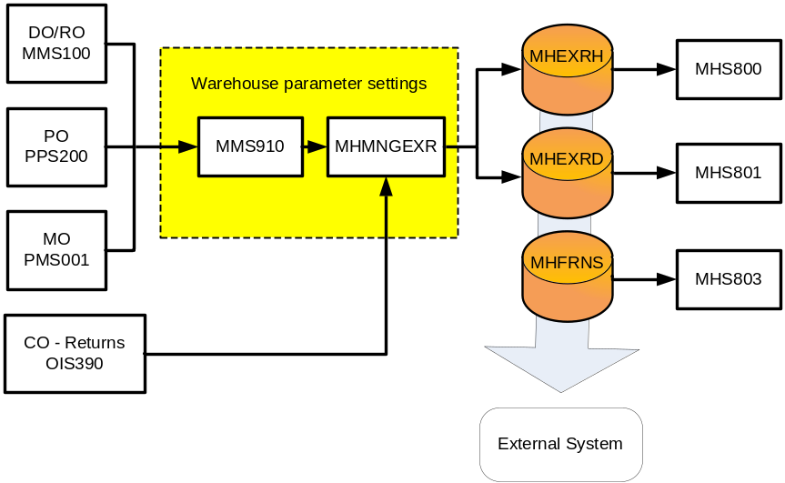

MHS800, MHS801, and MHS803 are M3 functions that monitor the expected receipt download files. The download files are MHEXRH, MHEXRD and MHFRNS. Receipt data is written to the files according to your warehouse parameters in MMS005.
MHS803 stores goods receipt DO line transactions if the transaction consists of several lots. You can access MHS803 by selecting Package (option 11) in MHS801. A rule of thumb to consider is that any change that can affect the material plan in M3 also updates the expected receipt files. A consequence of this rule is that only the changes on line level are captured and recorded.
Furthermore, some changes are filtered out to enable M3 to download only the relevant data. The command field (CMND) follows the update of the material plan (MITPLO) and can be used when building logic into the external system. The download flag (DOWN) is always set to zero "0" after M3 writes or updates a record. The tables below show how the command field reacts to different events.
Note: The tables describe normal events. Exceptions may exist depending on how M3 is configured in your environment.

The rest of the text in sample 2 removed on purpose.

Sample 3: Knowledge Base article

You will notice that our user manuals and KB articles do not share the same language and formatting standards. The language and formatting standards of our user manuals is rigid and structured, while our KB articles are relaxed, conversational, and written in a simple “Question and Answer” format.

Finding the API port number on different environments

Description:

I access the application program interfaces (API) on different environments such as Production, Testing, and Sandbox.

I want to find the API port number for each of these environments. How can I do that?

Solution:

Follow these steps on each environment to find the appropriate API port number:
- Access the Serverview.
- Select the Properties link. The Properties window opens.
- Search for the #port for batchdispatcher entry (highlighted in green). The API port number is directly below this entry.
Note: In this example, the API port number is 46800.
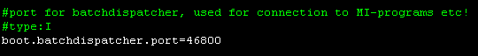

Sample 4: Simple decision-type flowchart for prime number testing

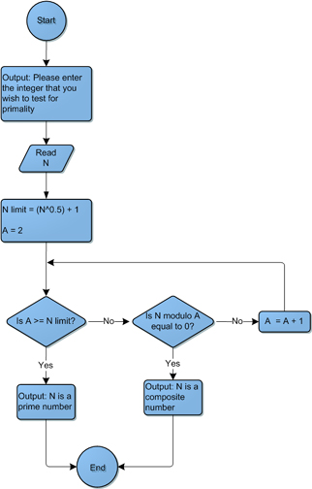
Sample 5: Supply Chain Management Process Flow

